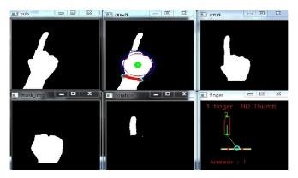

**Sign Language Dataset**

**Classification**

**Recognition of Sign in Text and output is expressed**

**Classification and**

**Recognition Stage**

**Image**

**Acquisition Devices**

Project Design Phase-II Technology Stack (Architecture & Stack)

|  |  |
| --- | --- |
| Date | 14 October 2022 |
| Team ID | PNT2022TMID46549 |
| Project Name | Project – Real Time Communication System Powered by AI For Specially Abled. |
| Maximum Marks | 4 Marks |



USER

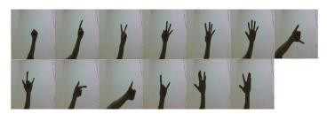

**Image Acquisition**

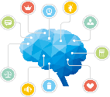

**Image**

**Pre-processing and segmentation Stage**

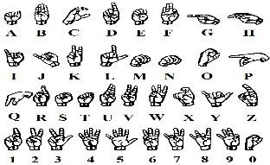



**Feature Extraction Stage**

**Extract Hand Features**

Table-1 : Components & Technologies:

|  |  |  |  |
| --- | --- | --- | --- |
| **S.No** | **Component** | **Description** | **Technology** |
| 1. | User Interface | Customer have to login through their respective website or phone number. Then interaction will happen with the User interface. | javascript, CSS,HTML |
| 2. | Application Logic-1 | It requires various types libraries, frameworks to develop the project | Java / Python |
| 3. | Application Logic-2 | Helps to converting the human gestures/actions into written words. | Machine learning |
| 4. | Application Logic-3 | Provides helpful,feasible answers after recognising the human gestures. | ANN,CNN |
| 5. | Database | Data could be numbers or words. | MySQL, Rational database |
| 6. | Cloud Database | Providing customer to use host database without buying additional hardware.. | Deep learning and neural networks |
| 7. | File Storage | File storage could be fast, reliable and flexible.. | Local file system |
| 8. | External API-1 | Used to access the information in the cloud | Weather API |
| 9. | External API-2 | Used to access the information for data driven decision making... | Aadhar API |
| 10. | Machine Learning Model | Machine learning interact with various algorithms that are required for implementation. | Image acquisation |
| 11. | Infrastructure (Server / Cloud) | Application deployment on local system /local cloud server configuration.  Install the windows version and execute the installer.. | Local, Cloud Foundry, Kubernetes, etc. |

Table-2: Application Characteristics:

|  |  |  |  |
| --- | --- | --- | --- |
| **S.No** | **Characteristics** | **Description** | **Technology** |
| 1. | Open-Source Frameworks | The framework which are used. | Tensor flow, Theano, RNN, PyTorch |
| 2. | Security Implementations | Security controls which can implemented by using firewall.. | Firewall and some security related softwares.. |
| 3. | Scalable Architecture | The architecture will be scalable (Micro services). | Data, models, speed and consistency.. |
| 4. | Availability | The availablity of application ( use of load balancers, distributed servers etc) | Image recognition, sign/gestures recognition, text recognition & real time captioning.. |
| 5. | Performance | Design aspects for the performance of application ( number of requests per second, use of cache etc.., | Using Convolutional neural network, maching learning for conversation and improve the sensivity of the performance.. |